Task on VPC-02

- Create one VPC, with 1 public subnet and 1 private subnet.
Create on vpc in ohio region with 172.168.0.0/24 CIDR
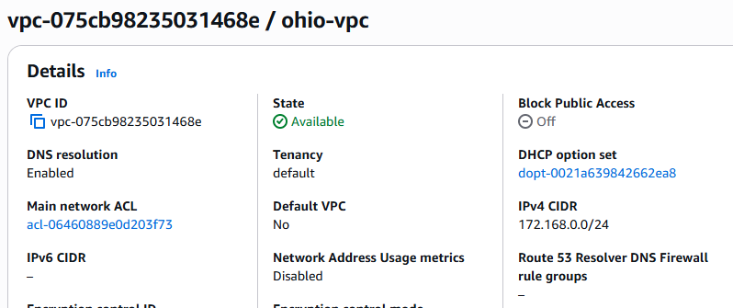
Create one public subnet and one private subnet and creat a public route table and private route table
in the public route table succociate with igw
in private route table do not add igw in the routes
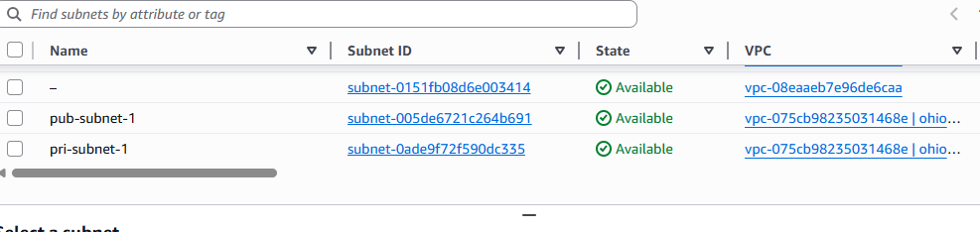

- Enable VPC peering for cross-region.
Creating peering connection with the another vpc in different region on same account
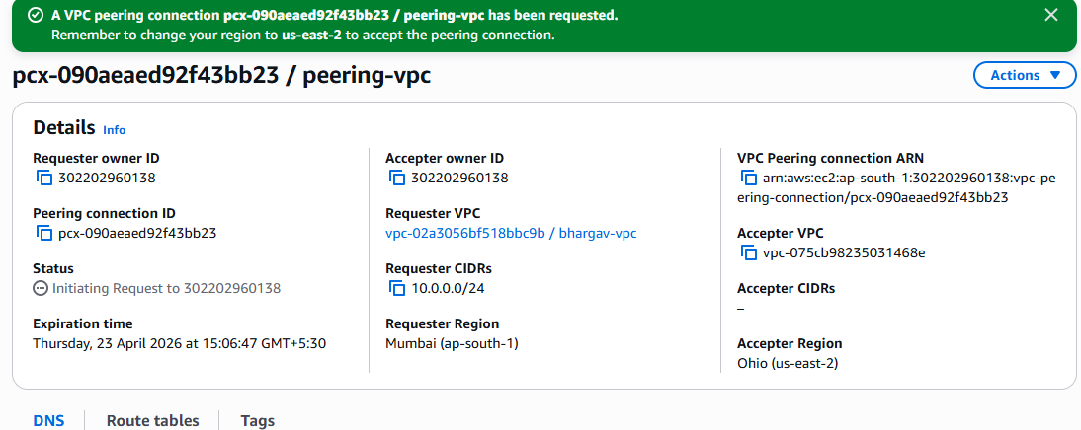
  - Then go the another region and go to peering connection and accept the request came from ohio region,allocate the cidr range in the route table
  - create two instances with different vpc
  - connect to the git bash with the one instance
  - check connectivity by using anithor instancse private ip address (by using ping command)
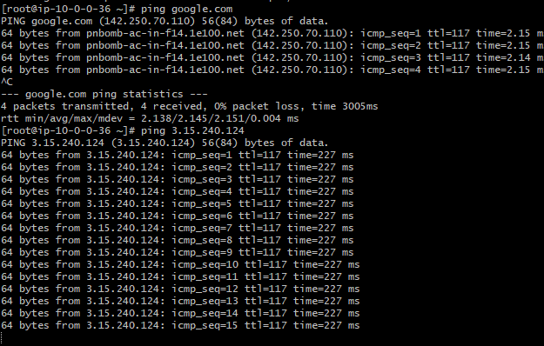
- Enable VPC peering for cross-account (you can collaborate with your friend to do this task).

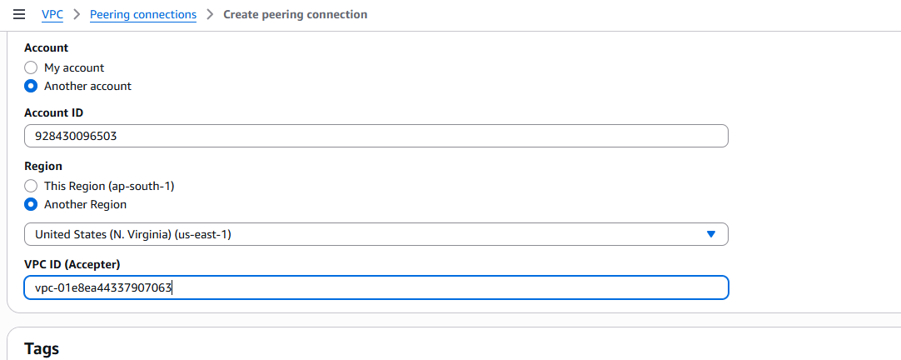
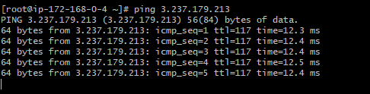

- Set up a VPC Transit Gateway.
Create multiple vpc in the region with public subnets and total configuration
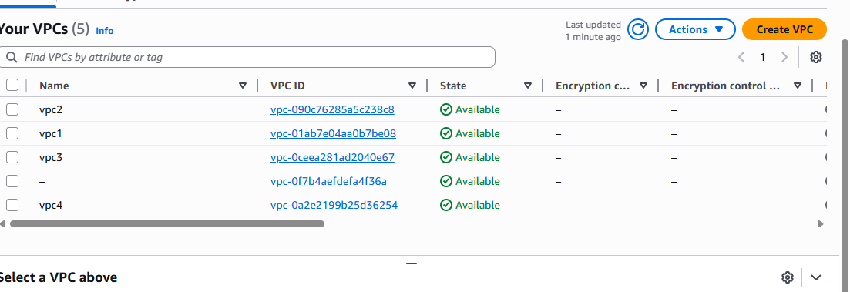

Create the instances by using which we created vpc’s earlier
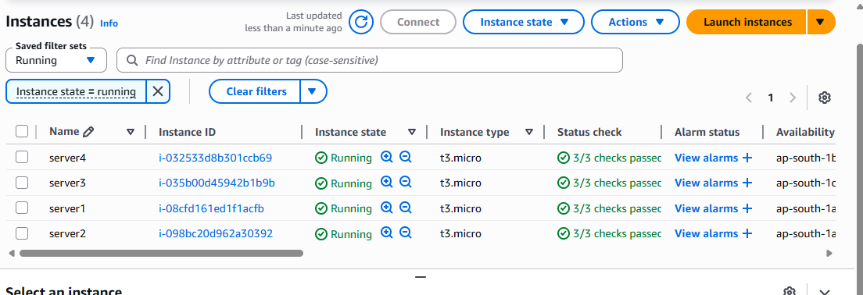
Create transitgateway
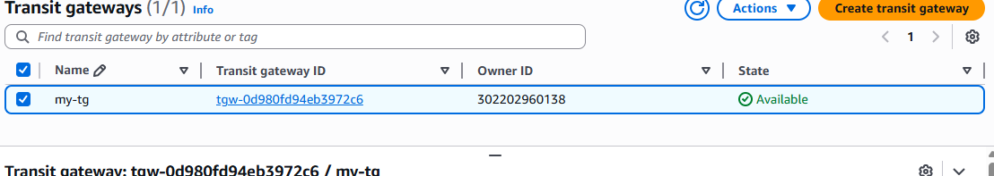
Create transit gateway attachments and attach to the vpc
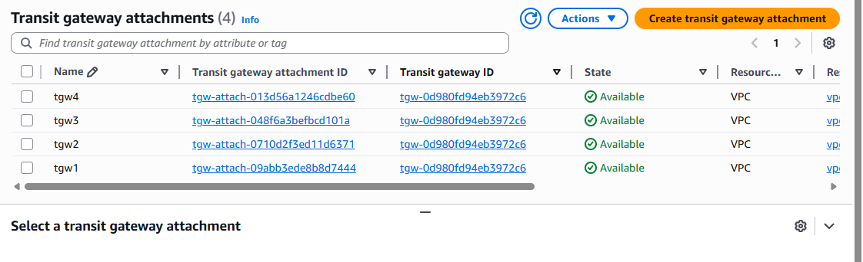

Check the transit gateway route table weather the attachments are associated with the route table
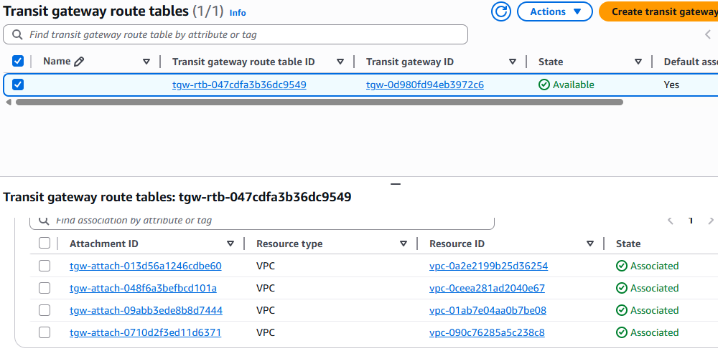
Coming to the route table of the vpc and the all CIDR’s in all route tables
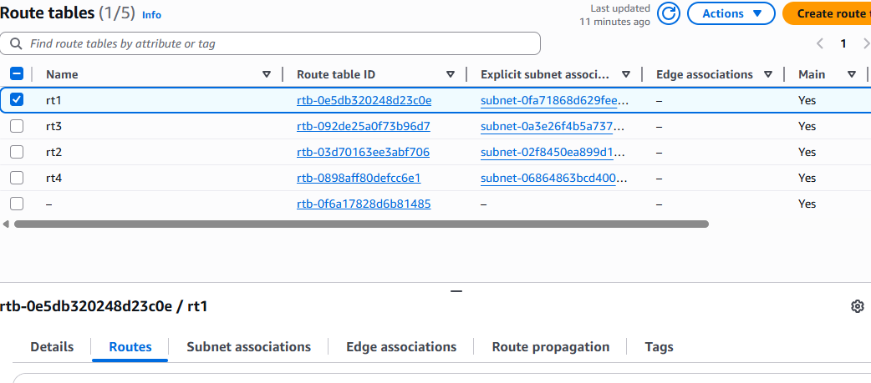
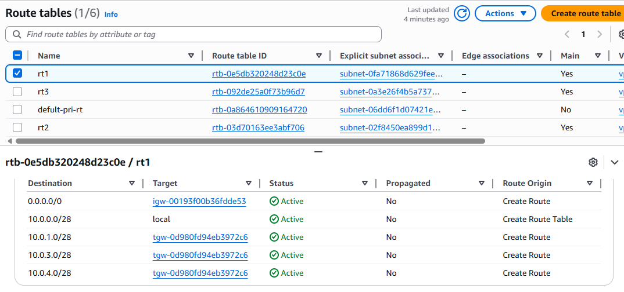
Connect to the one instance which we are created and check the connectivity different instance by using [ping command and private Ip address
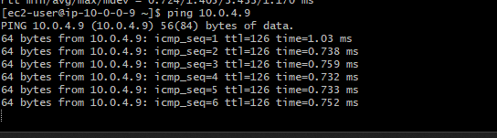

- Set up a VPC Endpoint.
Crate end point
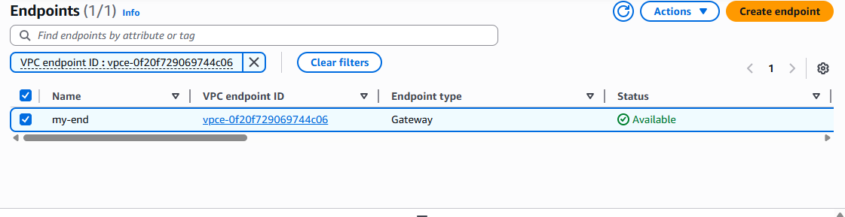

Select the s3 service and click the gateway
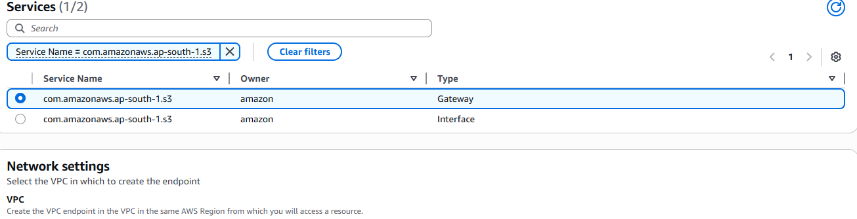
Add the vpc which you are using vpc for launch th eprivate instance.
add the private route table and click the create.
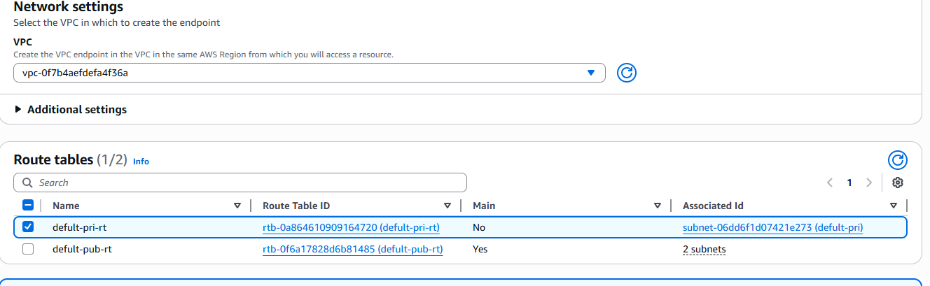
we can check the private route table and you will see the one route is created
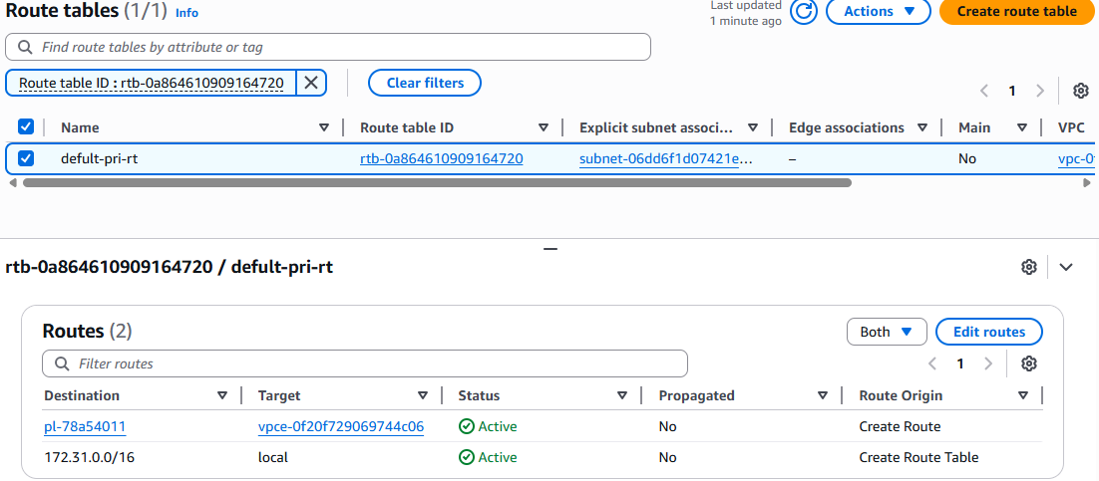

Here we can check through the aws CLI or git bash, without NAT gateway we are able to accessing the private instance
